**Draft of the COCA arc**

**Title:** Climate impacts, cross-fishery spillover, and ecosystem management strategy evaluation for US West Coast fisheries and fishing communities

**Goal:** fisheries practices and management strategies that are robust and resilient to future conditions in the CA Current

**Objectives:** develop management strategy evaluations that test current fishery practices and management systems to determine how status quo approaches will fare under a suite of climate-informed future scenarios; how they can be adjusted to mitigate impacts under each scenario; and what tradeoffs emerge for fishing communities, target and protected species, and management systems.

**Anticipated PIs:**

NWFSC: Harvey, Samhouri, Abrahms, Kaplan, Marshall, Moore, Richerson

SWFSC: Hazen, Jacox, Santora, Forney

UW: Jardine

(plus others TBA, e.g., Clarissa Anderson (and/or Jan Newton?), Matt Reimer, Kailin Kroetzer, Beth Fulton)

**Overview:**

* **Start high-level here - Climate change is expected to result in the shift of species across management boundaries and potential de-coupling/mismatch of predators and prey (Pinsky Science - Fish wars). Fisheries management structures need to be responsive to changing climate condition (discuss / cite BLOB BLOB2.0).**
* Under the Climate and Communities Initiative, the Council will be developing a suite of 3-5 qualitative, high-level scenarios that depict plausible conditions for the California Current in 2040; these will include climate conditions, demographics, economic conditions, technological changes, social factors, political context, etc. While these scenarios will not be fully developed until June 2020, potential examples that Jameal conjured up might include Winner-Take-All and Something-For-Everybody Scenarios:
  + Winner-Take-All: rise of big business fishing; pushing of state and local agendas; rapid technological advancement in fishing, fleets, and processors; pace of climate change accelerates
  + Something-For-Everybody: equity and inclusion given primary consideration in fisheries management; cooperation and coordination among federal, state, and local governments; fishing traditions and cultures preserved; climate change diminishes
* These scenarios will set a context within which stakeholders and managers will evaluate their current and future practices:
  + The Council will need to know if its current management structure is robust enough to meet its goals of sustainable fisheries and equitable allocation under all scenarios between now and the 2040s
  + Fisheries participants (at scales of vessels, ports, communities at sea) will need to understand and anticipate risks posed by external pressures and regulatory changes in order to adapt
  + NOAA will need to know how changing natural conditions and likely fisheries responses will affect the status of target and protected species
  + Each of these groups should be aware of tradeoffs that may come with changes and adaptations
  + Science support is needed for each of these decision points (the Climate and Communities Initiative will not provide any decision support)
* We will work with the Council, Council advisory bodies that represent fishery participants and eNGOs, and the NMFS West Coast Region to develop science support for informed decision-making by managers and stakeholders. We will do so through a management strategy evaluation that focuses on key groups of fisheries and protected species that are linked ecologically and through human activities. One way to think about this is as a stress test for current federal fisheries management practices in the context of climate change.

**Project narrative:**

* We will focus on a portfolio of fisheries, among which individual vessels frequently switch based on seasonality, demand, earning potential, availability, regulations, etc. The focal fisheries are Dungeness crab, Pink shrimp, and Groundfish.
* Both climate variability and change are likely to have fishery impacts thus two separate forcings will be explored.
  + Event-scale climate variability (ENSO, hypoxia, etc.)
  + Long-term climate change (driven through regionally downscaled ROMS forced by global climate model projections)
* Although we do not know all of the conditions and pressures that will be featured in the 3-5 CCI scenarios, we can anticipate several that will occur in all, namely:
  + Shifts in target and protected species distributions forced by event-scale variability and long-term climate change
  + Shifts in target and protected species productivity, forced by same
  + Episodic, widespread HABs, forced by same
  + (are there others that can/should be modeled and that fit into likely scenario scopes?)
* As an initial framing of the project, we are imagining:
  + ROMS-based climate and hydrology projections to 2040s (with ability to look beyond) that simulate change and interannual variability in temperature, oxygen, carbonate chemistry, circulation and nutrients, and HABs as an emergent property (leveraging future seas)
  + A model of fisher behavior that allows dynamic behavior in fishing location and participation/spillover across multiple fisheries (leveraging or new?)
  + An Atlantis ecosystem model that incorporates the ROMS and allows us to simulate future ecosystem states, shifting distributions of key species (groundfish, whales, crabs, shrimp) (new?)
  + An MSE (in Atlantis) in which we bring the above modules together to explore the ability of federal and state management plans to support sustainable harvests of groundfish, crab and shrimp in future climate scenarios; changes in the associated risk of blue and humpback whale entanglement; adaptability of fishers and what behaviors mitigate against future risks of revenue loss, fishery accessibility, etc.; and additional constraints or opportunities associated with CCI scenarios (new?)
  + A synthesis in which we translate the MSE into information relevant to fisheries and protected resource management at state and federal levels, and also relevant to fishery participants in different ports / regions (in partnership with a project “advisory board” with experts from Council, state agencies, industry, eNGOs)
  + See schematic below (some historic parts may be from other projects):

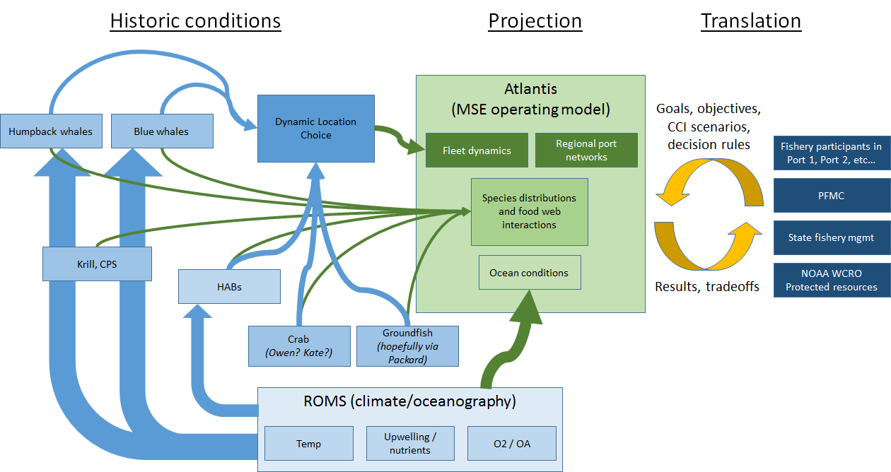

* We still need to work out all of the details, figure out what’s possible in the time and budget allotted, what is highest value, etc., and look forward to hearing your ideas in that process of figuring it all out.

**Skeleton Workplan:**

* Given anticipated changes, plus additional details that will be derived from the CCI scenarios, we will develop models that address the following questions:
  + How will event-scale variability and long-term climatology change between now and 2040s, and how might these changes (individually and cumulatively) affect the frequency, intensity, and spatial extent of harmful algal blooms and hypoxia events
    - Mike, Stephanie, Clarissa, Isaac, post-doc
    - Who else? Feel free to add your name
    - Mike and Stephanie: do you think this is something that a good post-doc could do, with sufficient guidance? Is there enough historic info to derive this? Do you have other ideas that relate to/stem from this?
  + How will species respond to projected changes between now and 2040s? Changes in distribution, productivity, etc. in response to exposure to pressures such as temperature, hypoxia and OA.
    - Isaac, post-doc, Jarrod, Kristin, Briana, Elliott
    - Who else? Feel free to add your name
    - Isaac: how many months of code development would be needed to get hypoxia into Atlantis? Also, in your previous Atlantis OA work, you wanted to follow up by having both temperature and OA as cumulative impacts, so this could be an opportunity to do that, and add hypoxia. That might appeal to Roger et al. as a means of greatly expanding biogeochemical capabilities in Atlantis models for all of NOAA. Is that something you think could happen in year 1 of a project period? (and in the meantime, you could get a tech/post doc up to speed, start running preliminary scenarios with ROMS projections, etc.)
    - Also, Isaac: can blue whales and humpback whales be separate functional groups?
  + Cross-fishery spillover: how will access to groundfish, crab and shrimp change for different vessel groups and ports as a function of changes developed above; how resilient/adaptable are vessels to changes as functions of location, vessel size/range, etc.; what alternatives are available for cross-fishery participation?
    - Dynamic location choice model
    - Sunny, other social scientist, post doc, Kate
    - Sunny: if this doesn’t make sense, it’s because I wrote it and it’s rather over my head...feel free to start making suggestions about what is both interesting and feasible
    - Who else? Feel free to add your name
  + MSE in Atlantis: Can status quo management by the Council and states successfully maintain sustainable populations of groundfish, minimize whale entanglement, and support viable fishing communities (particularly those targeting Dungeness crab) in the face of shifting environmental drivers, emergent stressors, and dynamic fisher behavior?
    - Atlantis post doc, Social science post doc, Kristin, Isaac, Jameal, Jarrod, Elliott, Sunny, Kate
    - (Everybody, probably!)
      * Isaac and Kristin: does this seem like something that could be done in Atlantis, and be led by the post doc, in year 3?
    - What steps are necessary for mitigation?
    - How do they vary across the CCI scenarios?
    - We will need to discuss **what the levers are** for this MSE:
      * there could be **federal management levers** to adjust while remaining consistent to the current groundfish FMP, ESA/MMPA, etc.
      * There can be **state-managed fishery levers**, e.g., changes to crab fishing as function of abundance, distribution, HABs, whale entanglement control rules, etc.
      * there could also be **fishing strategies** (“levers” adjusted by fishery practitioners) based on the dynamic location choice model; i.e., fishers adapting their practices within the constraints of the regulations
  + Tradeoffs: Are certain ports/regions/sectors likely winners/losers? Are certain species groups winners/losers?
    - Post docs, Kristin, Isaac, Sunny, Kate, Jarrod, Elliott, Jameal, Chris, et al
    - (Probably everybody again!)
    - Maybe, if time, can look at potential resilience of ports, of species groups, etc.; seems like that would be a direct application of the dynamic location choice effort
    - Could also be an opportunity to integrate, e.g., community vulnerability, port infrastructure, risk/exposure to sea level rise, …
    - Could also be a way to at least qualitatively apply CCI scenarios to different types of port (for example, economic and demographic trends might be very different depending on where you are)
* Translation of products to Council and other mgmt partners (who will be engaged and updated throughout)
  + Chris, Jameal, anyone else who wants to get involved

**IMPORTANT:**

Jameal advises that we should frame a COCA proposal not just in terms of the 3-yr project period, but also generally enough that it can be extended beyond the project period and perhaps translatable to other NOAA regions, so we can try to keep this reasonable and cost-appropriate for 3 years but also name projects that could be leveraged from it, such as:

* The dynamic location choice model
* MSE focused on whale entanglement, which would be applicable elsewhere (e.g., East Coast, potentially Arctic coast)
* Expanded Atlantis capabilities
* AND, we could extend the proposed MSE to include:
  + Other FMPs
  + Climate projections that run beyond the Climate and Communities Initiative window into the 2070s to see if planning for 2040 is adequate or short-sighted
  + MICE models to be developed in other parallel projects at different scales